Deadly bombings, naval blockades: Trump and Netanyahu continue to set the Middle East ablaze
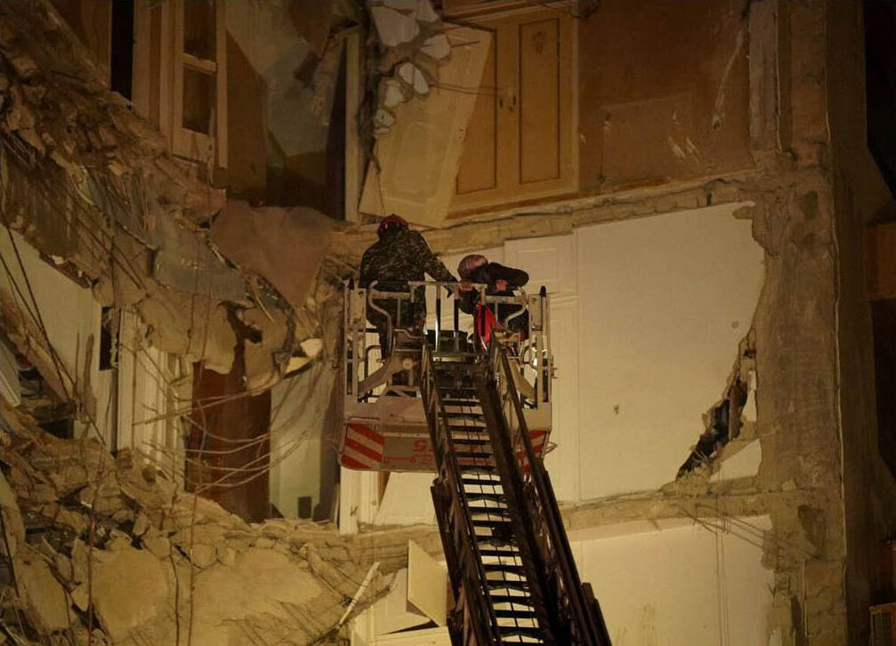
Beirut, April 8, 2026. Source: Wikipedia
On Tuesday, April 7, Donald Trump threatened to “wipe out a civilization”… before agreeing to a ceasefire with Iran in exchange for the reopening of the Strait of Hormuz. But after the first day of negotiations on Friday, April 10, U.S. Vice President J.D. Vance stormed out. The next day, Trump threatened to close the Strait of Hormuz again, then to impose a blockade on Iranian ports. The price of oil per barrel surged once more on international markets.
While the ceasefire in Iran and around the Persian Gulf is precarious, it does not apply to Lebanon. More than 350 people lost their lives in Israeli bombings on Wednesday, April 8, and dozens more in the days that followed. Since early March, the death toll has exceeded 2,000.

A war against the people and the working classes
Trump claims to have achieved a “total victory” against Iran and its nuclear program. But, amid threats of total destruction, ultimatums, periods of de-escalation, and gestures of outreach to the regime, he seems above all to be struggling to impose his will, as his Gulf allies want a return to calm, his Israeli partner pushes in the opposite direction, and his policy faces massive opposition in the United States.
No one could seriously believe that Trump and Netanyahu’s bombs would help Iran’s working class free itself from its oppressive regime. And in fact, the regime is holding firm, for now. While in December and January a popular uprising had shaken the regime, the bombings have only succeeded in further terrorizing the population and giving the regime a pretext to intensify repression. Since late March, at least seven people arrested during the protests have been put to death, and dozens more, including minors, face execution at any moment.

Down with French involvement!
The major powers and their allies defend only their own interests, their stranglehold on resources, and the fruits of the working classes’ labor. France and the European countries are no exception to this rule.
Macron may well disapprove of the war, and even refuse certain demands from Trump, but France is no less involved when it sends its aircraft carrier, frigates, and submarines to the eastern Mediterranean and the Gulf, when it participates in surveillance missions and the interception of drones and missiles, or when it offers to clear the Strait of Hormuz of mines.
And while the French government expresses concern for the fate of the Lebanese people, it is always to exonerate the Israeli government of the blood on its hands. Its sole ambition is to maintain its influence in Lebanon and the presence of its major corporations—at the risk of plunging the country back into a civil war that will target the working-class Shiites in the south of the country.
In France, the government is doing everything it can to prevent the exposure of the crimes committed by the imperialist powers and their Israeli accomplice. This is evident in the intimidation and arrests of activists working in solidarity with Palestine, as well as in the Yadan bill, which equates criticism of the Israeli state with anti-Semitism. But here, as elsewhere, no measure will silence the revolt and the international solidarity of the exploited!

